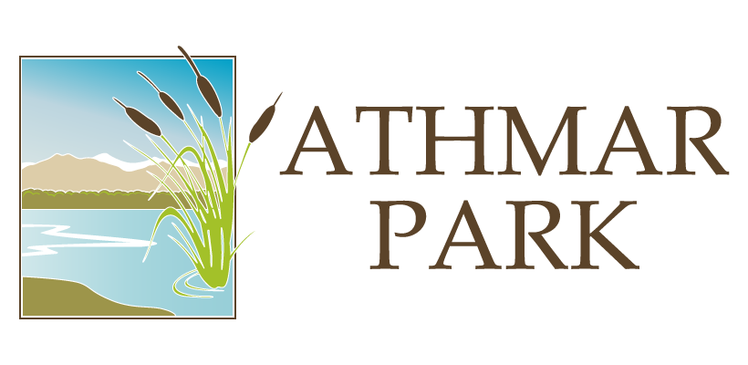

The Athmar Park Neighborhood Association (APNA) is an all-volunteer organization composed of residents and business owners working to improve the health, safety, and spirit of the area from West Alameda Avenue to West Mississippi Avenue and from the South Platte River to Federal Boulevard

La Asociación de Vecindarios de Athmar Park (APNA) es una organización compuesta exclusivamente por voluntarios y dueños de negocios que trabajan para mejorar la salud, la seguridad y el espíritu del área desde West Alameda Avenue hasta West Mississippi Avenue y desde South Platte River hasta Federal Boulevard

Support APNA by becoming a member
By Elizabeth Snow, Membership Secretary
We are running a membership challenge with a goal to have 10% of the neighborhood sign-up as members during 2018. Out of approximately 3500 households, we currently have 37 members, or approximately 1%.

New members will be entered into a raffle to win some awesome local goodies.

Help us meet the goal and support APNA by becoming a member today!

If you’ve enjoyed any of the APNA events, such as the summer picnic or movies in the park, or benefit from this newsletter, or you want to support and have a voice in this organization that is working to make Athmar Park a great place to live, please consider becoming a member.

What are the benefits of having a current membership with the organization?
- Regular, Senior, and Organizational members are able to vote in APNA elections! See below for more information on these types of membership
- Your dues go to the APNA general fund, which is used for neighborhood association activities and administration, including newsletter printing and community events

Types of Membership:
According to the APNA bylaws, there are four membership categories:
- Regular member ($10/year/household): any person eighteen years to sixty-four, who rents or owns property in the APNA geographic area, and who has paid annual membership dues as required for the current fiscal year. All adults living at one address shall pay one annual household dues; each adult is entitled to one vote.
- Senior member ($5/year/household): Eligibility: any person sixty-five and over, who rents or owns property in Athmar Park. All seniors living at one address shall pay one annual household dues; each senior is entitled to one vote
- Organizational member ($25/year): any club, church, business, educational institution, or other organization located in Athmar Park. One Organization representative is entitled to one vote.
- Associate member ($25/year): any person/organization that wishes to support the activities of APNA, but does not live or own property in Athmar Park. Associate member shall pay annual membership dues and receive the APNA newsletter. Associate members are not entitled to vote.

Membership dues cover the calendar year in which the dues are paid, so if you join any time during 2018, your membership will cover 2018.

How to become a member:
- Join online at http://athmarpark.com/apna-2/become-a-member/
- Mail a check to: APNA, P.O. Box 19732, Denver, CO 80219
- Pay at an event on the Stripe card reader
Join the Athmar Park Neighborhood Association (APNA) Today!
In Athmar Park, there are about 3500 households, and 37 registered members. Our goal is to bring this number up to 10% (350 members) by June 2019.

What does APNA do?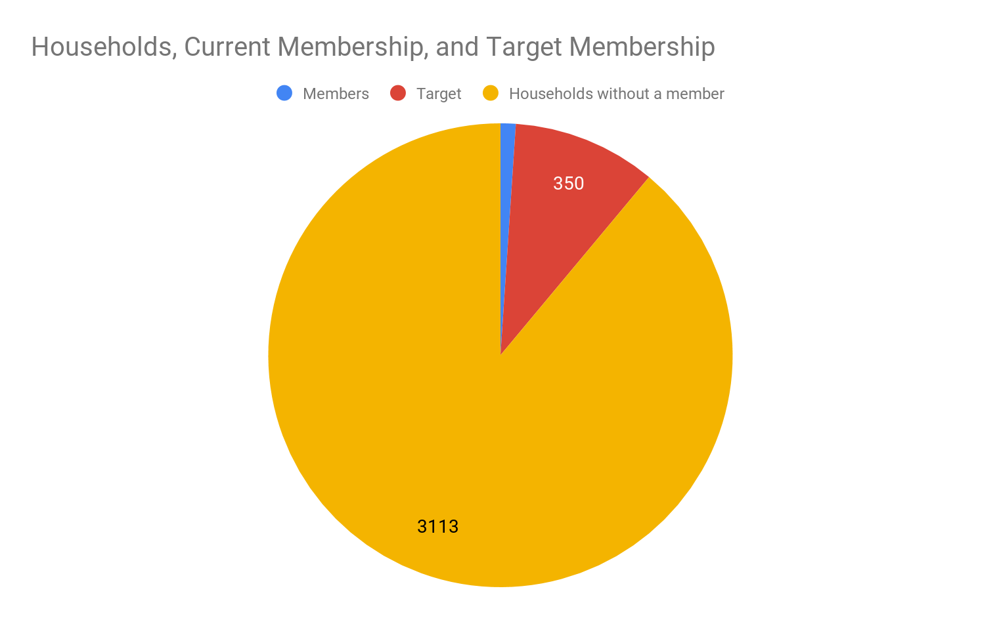
If you’ve enjoyed any of the APNA events, such as the summer picnic or movies in the park, or if you enjoy reading this newsletter, or you want to support and have a voice in this organization that is working to make Athmar Park a great place to live, please consider becoming a member.

How do I become an APNA Member?
Membership costs as little as $10/year. Here’s how to join:
- Join online at http://athmarpark.com/apna-2/become-a-member/
- Mail a check to: APNA, P.O. Box 19732, Denver, CO 80219
- Pay at an event (find our table!)
- Send an email to membership@athmarpark.com or contact Elizabeth Snow at 303-520-9957 for more information

Events  September  - Sept. 25 @ 6:30 p.m.: Monthly APNA Meeting*  October  - Oct. 15: Last day to nominate candidates for open positions (see elections insert)  - Oct. 23 @ 6:30 p.m.: Monthly APNA Meeting*  - Oct. 28 3 - 6 p.m.: “HalloweenFest” at Farmers Insurance, 1100 S Shoshone St. This event is hosted by Athmar Park & Ruby Hill Business Communities.  November  - Nov. 27 @ 6:30 p.m.: Monthly APNA Meeting*  December  - TBD: Annual Holiday Party  * Monthly APNA Meetings are held at Athmar Park Church, 2707 W Mississippi Ave, Denver, CO 80219 | Eventos  Septiembre  - 25 de septiembre a las 6:30 p.m .: Reunión mensual de APNA *  Octubre  - 15 de octubre: Último día para nominar candidatos para puestos vacantes (ver inserción de elecciones)  - 23 de octubre a las 6:30 p.m .: Reunión mensual de APNA *  - 28 de octubre 3 - 6 p.m.: "HalloweenFest" en Farmers Insurance, 1100 S Shoshone St. Este evento es organizado por Athmar Park y Ruby Hill Business Communities.  Noviembre  - 27 de noviembre a las 6:30 p.m .: Reunión mensual de APNA *  Diciembre  - A determinar: fiesta anual de vacaciones  * Las reuniones mensuales de APNA se llevan a cabo en Athmar Park Church, 2707 W Mississippi Ave, Denver, CO 80219


APNA Mission Statement, Vision, and Values
As previously announced online and at our meeting, the APNA board held two open meetings this summer to discuss and codify the principles and aims of our organization:

Mission
APNA’s mission is to build a safe, healthy, and vibrant neighborhood by:
- Providing forums for communication and cooperation
- Organizing for positive change
- Promoting involvement of all residents
- Working with city officials to advocate for community needs
- Addressing safety concerns
- Organizing community events
- Vision
APNA cultivates the neighborhood’s unique character, listens to residents, advocates for residents, and operates openly and fairly.

Values
- Striving for accountability and effectiveness
- Operating openly and fairly
- Maintaining respect and appreciation for each person’s beliefs, ideas, and opinions.
- Goals
- Provide forums for communication, cooperation, and community building. Specific events and activities for this goal include:
  - Monthly community meetings
  - Movies in the park
  - Summer picnic
  - Holiday party
  - Progressive dinners
  - Quarterly newsletters
  - New initiatives such as block parties, dumpster days, and “Neighbors Helping Neighbors” volunteer events
- Advocate and Organize for Positive Change
  - Have a board member expert on zoning
  - Increase engagement of residents, businesses, and organizations.
  - Collaborate with nearby neighborhoods.
  - Build network within the city and neighborhood.
  - Safe Streets Initiative
- Organizational Excellence
  - Maintain high member satisfaction
  - Maintain transparency and accountability.
  - Manage finances with excellence
- Board Openings and Election Information
Elections will be held for the following positions at the annual holiday party in December:

Board Members in the following positions are stepping down:
- At Large Board Member
- Southeast Quadrant Leader
- Treasurer
- Vice President

Thanks to Lavonne Gonzales, Brandon Parker, Graham Lightner, and Derek Medina, respectively, for their service.

The following Board Members are up for re-election:
- Nicole Guaydacan / Northwest Quadrant Leader
- Maria Irivarren / Northeast Quadrant Leader
- Flor Alvidrez / Southwest Quadrant Leader
- Elizabeth Snow / Membership Chair

Any APNA member can self-nominate or nominate any other member for any of the positions listed above. Nominees will meet with an existing board member prior to the election to review the responsibilities and expectations for the position they are interested in.

Please send your nominations to <nominations@athmarpark.com> no later than October 15!

Declaración de misión, visión y valores de APNA
Como se anunció previamente en línea y en nuestra reunión, el consejo de APNA celebró dos reuniones abiertas este verano para discutir y codificar los principios y objetivos de nuestra organización:

Misión
La misión de APNA es construir un vecindario seguro, saludable y dinámico a través de:
- Organizar foros de comunicación y cooperación
- Organizándose para un cambio positivo
- Promover la participación de todos los residentes
- Trabajar con los funcionarios de la ciudad para abogar por las necesidades de la comunidad
- Visión
APNA cultiva el carácter único del vecindario, escucha a los residentes, defiende a los residentes y opera abierta y justamente.

Valores
- Esforzarse por la responsabilidad y la eficacia
- Operando abiertamente y de manera justa
- Mantener respeto y aprecio por las creencias, ideas y opiniones de cada persona.
- Metas
- Organizar foros para la comunicación, la cooperación y la construcción de la comunidad. Los eventos y actividades específicos para este objetivo incluyen:
  - Reuniones comunitarias mensuale
  - Películas en el parque
  - Celebración de días festivos
  - Cenas progresivas
  - Boletines trimestrales
  - Nuevas iniciativas como fiestas en el patio, días en el contenedor de basura y eventos voluntarios de "Vecinos que ayudan a los vecinos"
- Abogar y organizarse para un cambio positivo
  - Tener un miembro del consejo experto en zonificación
  - Aumentar el compromiso de los residentes, negocios y organizaciones.
  - Colabora con vecindarios cercanos.
  - Construye una red dentro de la ciudad y el vecindario.
  - Iniciativa de Calles Seguras
- Excelencia Organizacional
  - Mantener una alta satisfacción de los miembros
  - Mantener la transparencia y la responsabilidad.
  - Administre las finanzas con excelencia
- Aperturas de la Junta e Información Electoral
Las elecciones se llevarán a cabo para los siguientes puestos en la fiesta anual de diciembre:
- Miembro de la Junta en general
- Líder del Cuadrante Sudeste
- Tesorero
- Vicepresidente

Gracias a Lavonne Gonzales, Brandon Parker, Graham Lightner y Derek Medina, respectivamente, por su servicio.

Los siguientes miembros de la Junta están listos para la reelección:
- Nicole Guaydacan / líder del cuadrante noroeste
- Maria Irivarren / Líder del Cuadrante Noreste
- Flor Alvidrez / líder del cuadrante suroeste
- Elizabeth Snow / Membresía Presidente

Cualquier miembro de APNA puede nominarse a sí mismo o nominar a cualquier otro miembro para cualquiera de los puestos mencionados anteriormente. Los nominados se reunirán con un miembro existente de la junta antes de la elección

¡Envíen sus nominaciones a <nominations@athmarpark.com> antes del 15 de octubre!
- Abordar las preocupaciones de seguridad
- Organizando eventos comunitarios

Events | Eventos
Athmar Park Neighborhood Association Meetings  Who:  What:  When: APNA meetings are on fourth Tuesday of each month, which means the next four will be held on the following dates:  - September *  - October *  - November *  - December *  Where:  Why: | Reuniones de Asociación de Vecindarios de Athmar Park  Quién:  Qué:  Cuándo: las reuniones de APNA son el cuarto martes de cada mes, lo que significa que las próximas cuatro se llevarán a cabo en las siguientes fechas:  - 22 de mayo  - Junio  - Julio  - augusto  Dónde:  Por qué:

Resources / Recursos
Abandoned Vehicles | 303-295-4367 | Vehículos abandonados
Alley Cleaning  (thru the Juvenile Youth Offender Program) | 311 | Limpieza de callejones  (a través del Programa de Delincuentes Juveniles)
Animal Abuse / Neglect | 303-923-0022 | Abuso / Negligencia de animales
Animal Control  (Head: Alice Nightingale) | 720-913-1311 | Control de anímales  (Cabecera: Alice Nightingale)
Athmar Branch Library | 720-865-0230 | Rama de la Biblioteca Athmar
Building Inspections | 720-865-2505 | Inspecciones de construcción
Building Permit Verification | 720-865-2790 | Verificación del permiso de construcción
City Council District 7 Representative  Jolon Clark | jolon.clark@denvergov.org / 720-337-7777 | Ayuntamiento del Distrito 7 Representante Jolon Clark
City Information | 311 or www.denvergov.org | Información de la ciudad
Community Resource Officer Alexis Aranda | Alexis.Aranda@denvergov.org / 720-913-0277 | Oficial de recursos comunitarios Alexis Aranda
Denver Mediation Center  (free help between neighbors) | 303-651-6534 | Centro de mediación de Denver  (ayuda gratuita entre vecinos)
DPS Security | 720-423-3911 | Seguridad DPS
Drug Hotline | 720-913-DRUG (3784) | Línea Directa de Drogas
Dumpster Violations / Illegal Dumping | 311 | Dumpster Violations / Dumping ilegal
Environmental Health (unsafe/over-crowded housing, food peddlers, noise/fumes) | 311 | Salud ambiental (viviendas inseguras / superpobladas, vendedores ambulantes de alimentos, ruido / humos)
Forestry | 720-913-0651 | Silvicultura
Gang Hotline | 303-331-5912 | Línea directa de pandillas
Graffiti | 311 /  https://www.denvergov.org/pocketgov/#/report-a-problem | Pintada
Inspector: Amy Crisler | amy.crisler@denvergov.org / 720-865-3251 | Inspector de Athmar Park: Amy Crisler
Neighborhood Inspection Services (NIS) | 311 or www.denvergov.org/311 | Servicios de inspección del vecindario (NIS)
Mayor’s Office Neighborhood Liaison | Tony Young: 720-865-9018 tony.young@denvergov.org | Oficina del Alcalde Enlace del Vecindario
Parks and Recreation | 720-913-1311 | Parques y Recreación
Planning and Development: Caryn Wenzara | 720-865-2940 | Planificación y desarrollo: Caryn Wenzara
Police Dispatch (non-emergency) | 720-913-2000 (main) 720-913-0200 (District 4 Station) | Despacho de la policía (no de emergencia)
Potholes | 311 | Baches
Right-of-Way / Dangerous Sidewalks | David Moo: 303-446-3687 | Derecho de paso / Aceras peligrosas
Strategic Crime Attack Team (SCAT) Supervisor | Tim Hiatt / 720-913-0233 | Supervisor de Strategic Crime Attack Team (SCAT)
Street Light Repair | Xcel Energy: 800-895-4999, #4 | Reparación de luz de calle
Trash & Large Item Pick-Up | 311 | Recogida de basura y artículos grandes
Wastewater Hotline | 303-446-3700, #1 | Línea Directa de Aguas Residuales
Zoning / Permits | 720-865-3000 | Zonificación / Permisos

APNA Board Members
In December 2017, The Athmar Park Neighborhood Association elected new board members:

Position | Name | Phone | Email
President | Ken Knoblock | 303-549-9410 | kknoblock@gmail.com
Vice President | Derek Medina | 303-619-5830 | dvsnzxy@gmail.com
Secretary | Kristin Lacy | 405-742-7844 | Lacy.kristin@gmail.com
Treasurer | Graham Lightner | 303-478-1524 | graham.lightner@gmail.com
Membership | Elizabeth Snow | 303-520-9957 | elizabethsnow9@hotmail.com
Newsletter Editor | Ian Melchior | 720-204-8426 | ian.melchior@gmail.com
NE Quadrant Leader | Maria Irivarren | 720-309-8649 | maria.irivarren@8z.com
SE Quadrant Leader | Brandon Parker | 720-202-4254 | brandon.parker35@gmail.com
SW Quadrant Leader | Flor Alvidrez | 720-024-7793 | florcristal@gmail.com
NW Quadrant Leader | Nicole Guaydacan | 303-801-8781 | niccola24@yahoo.com
At-Large | Bonnie Laws |  | bvlaws@gmail.com
At-Large | Charles Van Atta | 720-841-3369 | Rascalduran@yahoo.com
At-Large | Helena Karchere | 310-384-5260 | helenaann@gmail.com
At-Large | Lavonne Gonzales | 970-420-5119 | lavonne_gonzales@yahoo.com

Special Thanks  - Spring 2018 Distributors:  - Erran and Lindsay Willoughby  - Derek Medina  - Melissa Gray  - Kristin Lacy  - Ken Knoblock  - Charles Van Atta  - Laura Park | Agradecimiento especial  - Patrocinadores:  - Sanda and Laura  - Mark Angelos  - Graham and Maggie Lightner  - Darby Cade  - Nicole and Dan Encinias  - Glen  - Maria Irivarren

